**Lab 4**

Q.1.

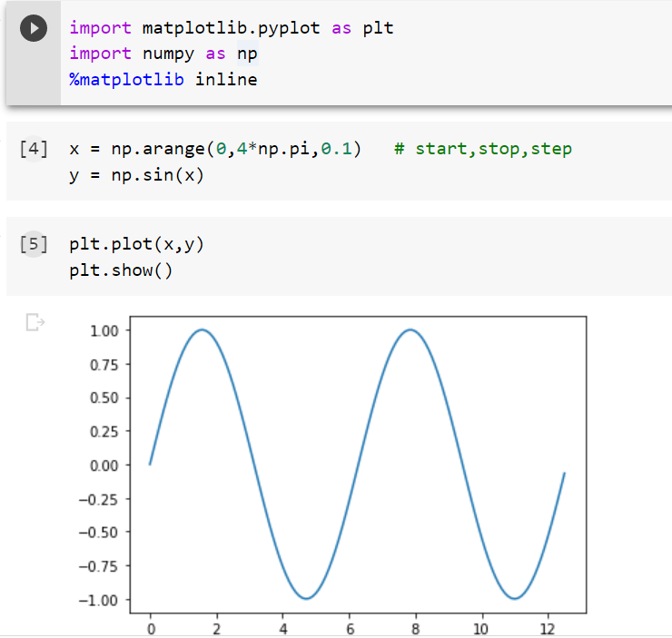

Q.6.

x+5y=7 —(1)

3x+4y=10 —(2)

Solving above eq. we get x=2 and y-1

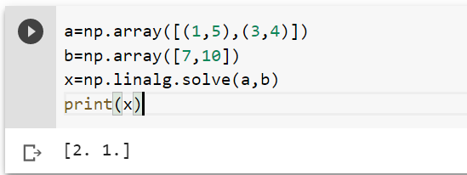

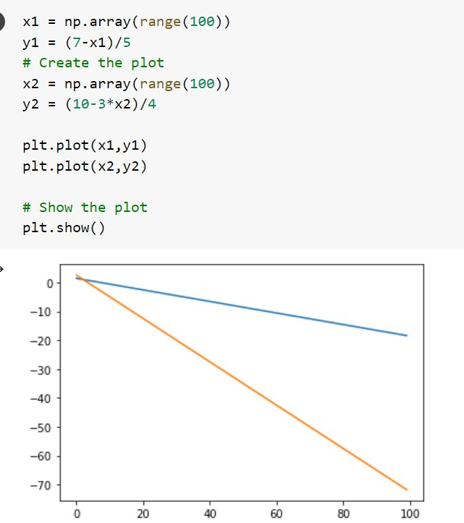Q. 5

Q